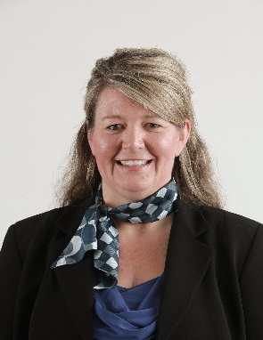  Donna M. Wildes  Vice President, Operations  First American Title Insurance Company  1855 Gateway Blvd, Ste 700  Concord, CA 94520  T 925.688.3245  dwildes@firstam.com | With more than 20 years of diverse experience in the title business, Donna Wildes serves as Vice President, Operations at First American Title. Throughout her tenure with First American, Donna has held roles in operations, business development, project management, product ownership, sales and customer support. Donna has a proven track record in executing strategic initiatives focused on process improvement, automation, quality control and fraud prevention.  Donna was a selected member of First American Title’s Women in Leadership Class of 2014 (WIL-14). She was a key contributor in establishing and implementing the company’s Enterprise Fraud Council (EFC).The EFC is tasked with putting in place a formalized structure to identify, mitigate and manage fraud vulnerabilities. It helps keep employees informed and proactive about fraud prevention while investigating emerging fraud schemes. Donna is currently acting as Chair of this council.  First American Title Insurance Company, the largest subsidiary of First American Financial Corporation (NYSE: FAF), traces its history to 1889. One of the largest title insurers in the nation, the company offers title services through its direct operations and an extensive network of agents throughout the United States and abroad. First American Title provides comprehensive title insurance coverage and professional services for real estate purchases, construction, refinances, and equity loans. The company has its headquarters in Santa Ana, Calif. Information about First American Financial Corporation’s subsidiaries and an archive of its press releases can be found at www.firstam.com.

