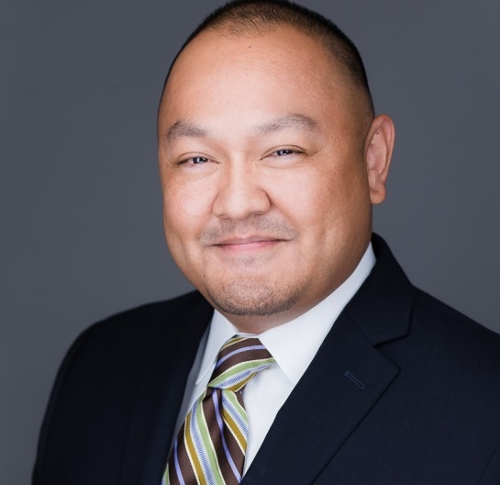  Ron Ampie  Loss Prevention Manager, Corporate Underwriting Department  First American Title Insurance Company  5 First American Way  Santa Ana, CA 92707  T 714.250.4801  rampie@firstam.com | Ron Ampie serves as Loss Prevention Manager in the Corporate Underwriting Department of First American Title Insurance Company. Ron is responsible for the review and analysis of national claims data and transactional history to identify trends and underwriting risk areas of concern, as well as recommending and implementing loss-prevention strategies and practical procedural improvements to enhance underwriting excellence and minimize underwriting risks.  A seasoned veteran of the title insurance industry, Ron first joined First American in 2003 as a Commercial Title Examiner for the National Production Services Division and, later served as a Title Officer for the Homebuilder Services Division. In 2010, Ron took a role as Title Operations Manager for HLC Settlement Services, Inc., a Discover Financial Services Company, before returning to First American in 2015.  Ron holds a Bachelor of Arts in Political Science from the University of California, Irvine. He also holds an Accredited Mortgage Professional Designation from the School of Mortgage Banking through the Mortgage Bankers Association.  First American Title Insurance Company, the largest subsidiary of First American Financial Corporation (NYSE: FAF), traces its history to 1889. One of the largest title insurers in the nation, the company offers title services through its direct operations and an extensive network of agents throughout the United States and abroad. First American Title provides comprehensive title insurance coverage and professional services for real estate purchases, construction, refinances, and equity loans. The company has its headquarters in Santa Ana, Calif. Information about First American Financial Corporation’s subsidiaries and an archive of its press releases can be found at www.firstam.com.

